PRE-EXPERIMENT QUIZ

- A radar transmitter feeds high power to an antenna. Show how a directional coupler may be connected to monitor power fed to the antenna.
- Show how a dual directional coupler may be used to monitor incident power as well as reflected power from a device.
- What is the effect of finite directivity when a coupler is used to monitor reflected power?
- For the 4-port directional coupler (Fig.1) assume that
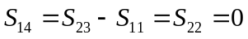
and 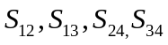not equal to zero. Show that such a device has all four ports matched
- Describe the construction and principle of operation of a two-hole waveguide coupler. With what modification one may achieve good directivity over a wide hand of frequencies?

